JS Apps Exam – SeenIt Single Page Application
You are assigned to implement a Web application (SPA) using HTML5, JavaScript, AJAX, REST and JSON with cloud-based backend (Kinvey). The app keeps users, posts and comments. Users can register, login, logout , view a catalog with all posts sorted by time (a helper function will be given), create a post, edit/delete their own posts, view a post with it’s comments, create a comment, delete their own comments and a section where they can view their own posts.
Using libraries like jQuery, Handlebars and Sammy is allowed but is not obligatory.

Create a Kinvey REST Service
Register at Kinvey.com and create an application to keep your data in the cloud.
In the Users collection, import the provided JSON file with sample users to get started with template data. In the Kinvey Console, select Users from the navigation of the left, click Settings in the upper right then scroll down to the Import section: 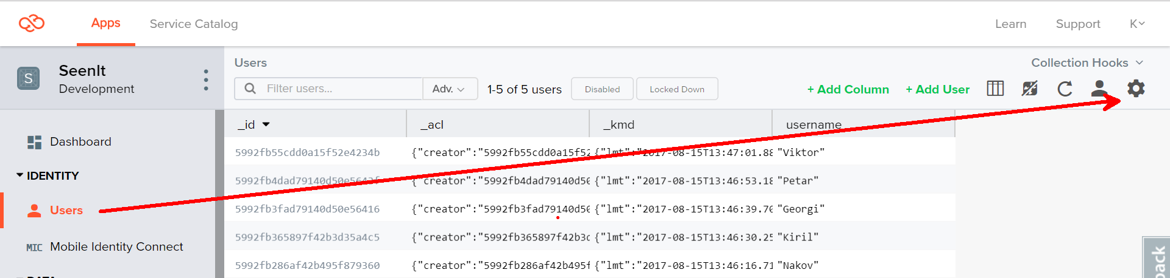
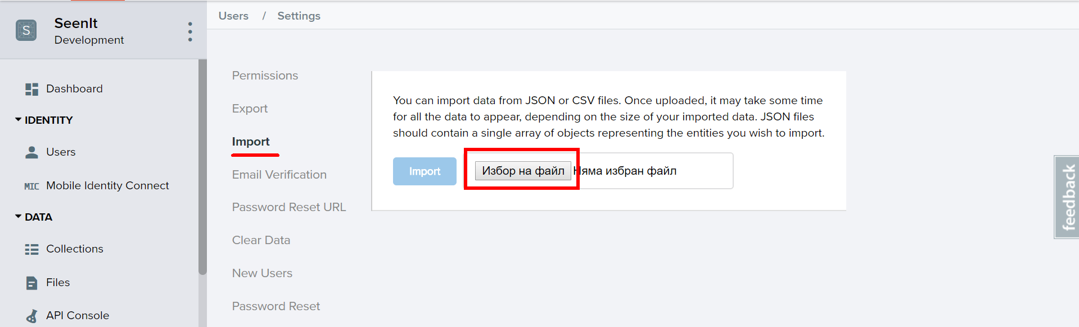
Create a collection posts. Each post has a url (a link to website), title, imageUrl, description and an author (username of the author).
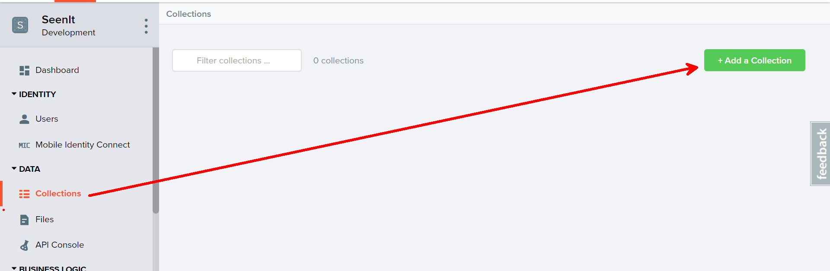
Create a collection comments. Each comment has postId, content and author (username of the author).
You are also given two more json files to import data for posts and comments.

Test the Kinvey REST Services
Using Postman or other HTTP client tool (you can use Kinvey’s built-in API Console), test the REST service endpoints:

User Registration (Sign Up)
POST https://baas.kinvey.com/user/app_id/
Request headers | Authorization: Basic base64(app_id:app_secret)  Content-Type: application/json
Request body | {  "username": "testuser",  "password": "testuserpass890"  }
Response  201 Created | {  "_id": "59930c78a743e20c7d3fca77",  "username": "testuser",  "password": "testuserpass890"  }
Error response  409 Conflict | { "error": "UserAlreadyExists", "description": "This username is already taken. Please retry your request with a different username", "debug": "" }
Error response  401 Unauthorized | { "error": "InvalidCredentials", "description": "Invalid credentials. Please retry your request with correct credentials", "debug": "" }
The request needs “Basic” authentication. Use the Kinvey App Key and Kinvey App Secret as credentials.
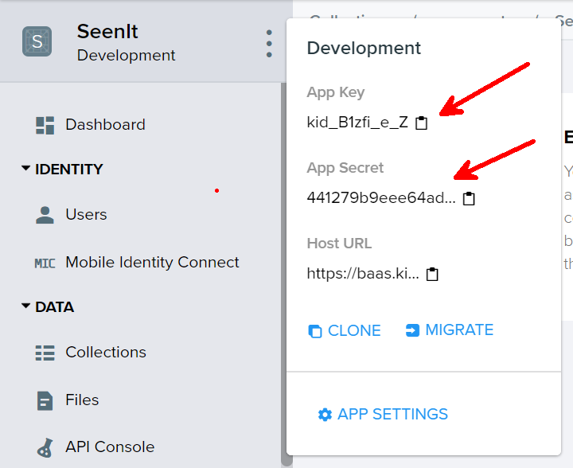

User Login
POST https://baas.kinvey.com/user/app_id/login
Request headers | Authorization: Basic base64(app_id:app_secret)  Content-Type: application/json
Request body | {  "username": "testuser",  "password": "testuserpass890"  }
Response  200 OK | {  "_id": "59930c78a743e20c7d3fca77",  "username": "testuser"  "_kmd": {  "authtoken": "8e6471bc-3712-4cfb-b92e-50e62a0c80….Duj5fHdM /7XHIe6KdY="  …  },  …  }
Error response  401 Unauthorized | { "error": "InvalidCredentials", "description": "Invalid credentials. Please retry your request with correct credentials", "debug": "" }
Successful login returns an “authtoken” which is later used to authenticate the CRUD operations.

User Logout
POST https://baas.kinvey.com/user/app_id/_logout
Request headers | Authorization: Kinvey authtoken
Response
204 No Content
Error response  401 Unauthorized | { "error": "InvalidCredentials", "description": "Invalid credentials. Please retry your request with correct credentials", "debug": "" }
To logout, you need to provide the “authtoken” given by login / register as “Kinvey” authorization header.

List all Posts (Catalog – sorted by post time, descending)
GET https://baas.kinvey.com/appdata/app_id/posts?query={}&sort={"_kmd.ect": -1}
Request headers | Authorization: Kinvey authtoken
Response  200 OK | [  {  "_id": "599307d36af42b495f87bad2",  "author": "Kiril",  "description": "My GitHub profile",  "url": "https://github.com/k1r1L",  "title": "GitHub",  "imageUrl": "https://pbs.twimg.com/profile_images/616309728688238592/pBeeJQDQ.png",  "_acl": {  "creator": "kid_B1zfi_e_Z"  },  "_kmd": {  "lmt": "2017-08-15T14:40:19.182Z",  "ect": "2017-08-15T14:40:19.182Z"  }  },...  ]
Error response  401 Unauthorized | { "error": "InvalidCredentials", "description": "Invalid credentials. Please retry your request with correct credentials", "debug": "" }

Create Post
POST https://baas.kinvey.com/appdata/app_id/posts
Request headers | Authorization: Kinvey authtoken  Content-Type: application/json
Request body | {  "author": "Kiril",  "title": "Test Post",  "description": "Test Post Description",  "url": "https://en.wikipedia.org/wiki/Santorini",  "imageUrl":"http://sailing-santorini.com/wp-content/uploads/2015/10/sunset-oia 500x500.jpg"  }
Response  201 Created | {  "_id": "59931398996ab5127d2a84d1",  "author": "Kiril",  "title": "Test Post",  "description": "Test Post Description",  "url": "https://en.wikipedia.org/wiki/Santorini",…  }
Error response  401 Unauthorized | { "error": "InvalidCredentials", "description": "Invalid credentials. Please retry your request with correct credentials", "debug": "" }

Edit Post
PUT https://baas.kinvey.com/appdata/app_id/posts/post_id
Request headers | Authorization: Kinvey authtoken  Content-Type: application/json
Request body | {  "author": "Kiril",  "title": "Test Post Edited",  "description": "Test Post Description Edited",  "url": "https://en.wikipedia.org/wiki/Santorini",  "imageUrl":"http://sailing-santorini.com/wp-content/uploads/2015/10/sunset-oia 500x500.jpg"  }
Response  200 Ok | {  "_id": "59931398996ab5127d2a84d1",  "author": "Kiril",  "title": "Test Post Edited",  "description": "Test Post Description Edited",  "url": "https://en.wikipedia.org/wiki/Santorini",…  }
Error response  401 Unauthorized | { "error": "InvalidCredentials", "description": "Invalid credentials. Please retry your request with correct credentials", "debug": "" }

Delete Post
DELETE https://baas.kinvey.com/appdata/app_id/posts/post_id
Request headers | Authorization: Kinvey authtoken
Response  200 OK | {  "count": 1  }
Error response  404 Not Found | { "error": "EntityNotFound", "description": "This entity not found in the collection", "debug": "" }
Error response  401 Unauthorized | { "error": "InvalidCredentials", "description": "Invalid credentials. Please retry your request with correct credentials", "debug": "" }

My Posts (View all posts by logged in user, sorted by post time, descending)
GET https://baas.kinvey.com/appdata/app_id/posts?query={"author":"username"}&sort={"_kmd.ect": -1}
Request headers | Authorization: Kinvey authtoken
Response  200 OK | [  {  "_id": "599307d36af42b495f87bad2",  "author": "Kiril",  "description": "My GitHub profile",  "url": "https://github.com/k1r1L",  "title": "GitHub",  "imageUrl": "https://pbs.twimg.com/profile_images/616309728688238592/pBeeJQDQ.png",  "_acl": {  "creator": "kid_B1zfi_e_Z"  },  "_kmd": {  "lmt": "2017-08-15T14:40:19.182Z",  "ect": "2017-08-15T14:40:19.182Z"  }  },  {  "_id": "5993178dbce993cf532bbe29",  "author": "Kiril",  "title": "Test Post",  "description": "Test Post Description",  "url": "https://en.wikipedia.org/wiki/Santorini",  "imageUrl": "http://sailing-santorini.com/wp-content/uploads/2015/10/sunset-oia-500x500.jpg",  "_acl": {  "creator": "59930c78a743e20c7d3fca77"  },  "_kmd": {  "lmt": "2017-08-15T15:47:25.376Z",  "ect": "2017-08-15T15:47:25.376Z"  }  }  ]
Error response  401 Unauthorized | { "error": "InvalidCredentials", "description": "Invalid credentials. Please retry your request with correct credentials", "debug": "" }

Post Details (View Post Comments)
GET https://baas.kinvey.com/appdata/app_id/posts/post_id
Request headers | Authorization: Kinvey authtoken
Response  200 OK | [  {  "_id": "599307d36af42b495f87bad2",  "author": "Kiril",  "description": "My GitHub profile",  "url": "https://github.com/k1r1L",  "title": "GitHub",  "imageUrl": "https://pbs.twimg.com/profile_images/616309728688238592/pBeeJQDQ.png",  "_acl": {  "creator": "kid_B1zfi_e_Z"  },  "_kmd": {  "lmt": "2017-08-15T14:40:19.182Z",  "ect": "2017-08-15T14:40:19.182Z"  }  }  ]
Error response  401 Unauthorized | { "error": "InvalidCredentials", "description": "Invalid credentials. Please retry your request with correct credentials", "debug": "" }

Note: Keep in mind that the quotes used in the query must be exactly double quotes(").
GET https://baas.kinvey.com/appdata/app_id/comments?query={"postId":"post_id"}&sort={"_kmd.ect": -1}
Request headers | Authorization: Kinvey authtoken
Response  200 OK | [  {  "_id": "599309bdbce993cf532b9643",  "postId": "599307d36af42b495f87bad2",  "author": "Nakov",  "content": "Very cool profile",  "_acl": {  "creator": "kid_B1zfi_e_Z"  },  "_kmd": {  "lmt": "2017-08-15T15:50:59.486Z",  "ect": "2017-08-15T14:48:29.551Z"  }  },  {  "_id": "59930a34133f6d253dfe31c9",  "postId": "599307d36af42b495f87bad2",  "content": "Nice!",  "author": "Viktor",  "_acl": {  "creator": "kid_B1zfi_e_Z"  },  "_kmd": {  "lmt": "2017-08-15T14:52:46.189Z",  "ect": "2017-08-15T14:50:28.536Z"  }  },..  ]
Error response  401 Unauthorized | { "error": "InvalidCredentials", "description": "Invalid credentials. Please retry your request with correct credentials", "debug": "" }

Create Comment
POST https://baas.kinvey.com/appdata/app_id/comments
Request headers | Authorization: Kinvey authtoken  Content-Type: application/json
Request body | {  "postId": "5993178dbce993cf532bbe29",  "content": "Very nice post",  "author": "Kiril"  }
Response  201 Created | {  "postId": "5993178dbce993cf532bbe29",  "content": "Very nice post",  "author": "Kiril",  "_acl": {  "creator": "59930c78a743e20c7d3fca77"  },...  }
Error response  401 Unauthorized | { "error": "InvalidCredentials", "description": "Invalid credentials. Please retry your request with correct credentials", "debug": "" }

Delete Comment
DELETE https://baas.kinvey.com/appdata/app_id/comments/comment_id
Request headers | Authorization: Kinvey authtoken
Response  200 OK | {  "count": 1  }
Error response  404 Not Found | { "error": "EntityNotFound", "description": "This entity not found in the collection", "debug": "" }
Error response  401 Unauthorized | { "error": "InvalidCredentials", "description": "Invalid credentials. Please retry your request with correct credentials", "debug": "" }

SeentIt–HTML and CSS
You аre given the Web design of the Messages application as HTML + CSS files.
- Initially all views and forms are shown by the HTML. Your application may hide by CSS (display: none) or delete from the DOM all unneeded elements or just display the views it needs to display.
- You may render the views / forms / components with jQuery or Mustache Handlebars.
Important: don’t change the elements’ class name and id. Don’t rename form fields / link names / ids. You are allowed to add data attributes to any elements. You may modify href attributes of links and add action/method attributes to forms, to allow the use of a routing library.

SeenIt Client-Side Web Application
Design and implement a client-side front-end app (SPA) for managing posts and comments. Implement the functionality described below.

Notifications
The application should notify the users about the result of their actions.
- In case of successful action an informational (green) notification message should be shown, which disappears automatically after 3 seconds or manually when the user clicks it.
- In case of error, an error notification message (red) should be shown which disappears on user click.
- During the AJAX calls a loading notification message (blue) should be shown. It should disappear automatically as soon as the AJAX call is completed.

Navigation System (5 pts)
Implement a navigation system for the app: navigation links should correctly change the current screen (view).
- Clicking on the links in the sidebar or the links on each individual post should display the view behind the link (views are sections in the HTML code).
- Your application may hide by CSS (display: none) or delete from the DOM all unneeded elements or just display the views it needs to display.
- The given „Navigation“ sidebar should be visible only for logged in users. Anonymous users can only view the sign in/register section.

Register User (10 pts)
By given username, password and repeat password the app should register a new user in the system.
- After a successful registration, a notification message “User registration successful.” should be displayed and the catalog with all posts should be shown.
- You need to validate the input. A username should be at least 3 characters long and should contain only english alphabet letters. A user‘s password should be at least 6 characters long and should contain only english alphabet letters and digits. Both passwords should match.
- In case of error (eg. invalid username/password), an appropriate error message should be displayed and the user should be able to try to register again.
- Keep the user session data in the browser’s session storage.
- Clear all input fields after successful login.
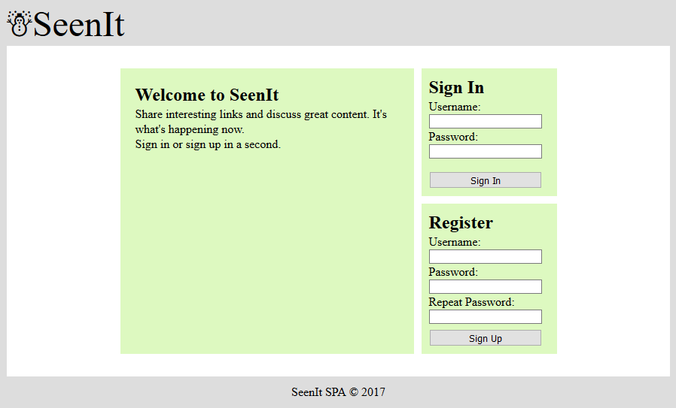

Login User (5 pts)
By given username and password the app should be able to login an existing user.
- After a successful login, a notification message “Login successful.” should be displayed and the user home screen should be displayed.
- In case of error, an appropriate error message should be displayed and the user should be able to fill the login form again.
- Form validation should be the same as register.
- Keep the user session data in the browser’s session storage.
- Clear all input fields after successful login.
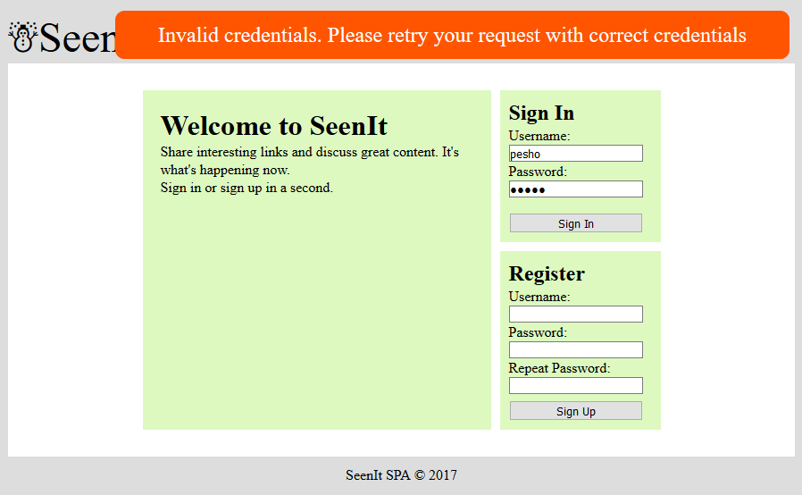

Logout (5 pts)
Successfully logged in user should be able to logout from the app.
- After a successful logout, a notification message “Logout successful.” should be displayed.
- After successful logout, the Sign In screen should be shown.
- The “logout” REST service at the back-end should be obligatory called at logout.
- All local information in the browser (user session data) about the current user should be deleted.

Catalog Screen (20 pts)
Successfully logged users should be welcomed by the catalog screen which can be accessed after clicking the [Catalog] link in the sidebar. The catalog contains all posts on the site.
- The posts should be listed in the format as shown in the Web design (see the screenshot below).
- Each post has title, url, imageUrl (optional), description (optional), rank (order number) and information about when it was created. For the time created information you will use a helper function given below. It requires a parameter which is the entity creation date of the post (or _kmd.ect property of the post object).
- When the comments link is clicked, your app should redirect to the details section of the post with comments.
- Post authors can edit/delete their own posts.
- In case of error (e.g. Internet connection lost), an error message should be displayed.
- In case of no posts, display ‘No posts in database’.
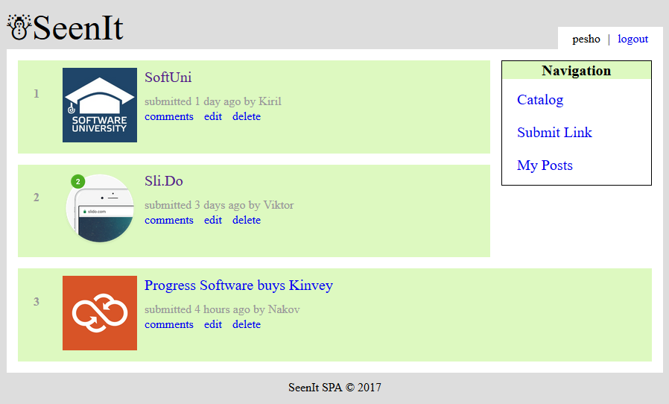
- Format the entity creation date of a post as shown in the screenshot above. You may use the following helper function:
function calcTime(dateIsoFormat) {
let diff = new Date - (new Date(dateIsoFormat));
diff = Math.floor(diff / 60000);
if (diff < 1) return 'less than a minute';
if (diff < 60) return diff + ' minute' + pluralize(diff);
diff = Math.floor(diff / 60);
if (diff < 24) return diff + ' hour' + pluralize(diff);
diff = Math.floor(diff / 24);
if (diff < 30) return diff + ' day' + pluralize(diff);
diff = Math.floor(diff / 30);
if (diff < 12) return diff + ' month' + pluralize(diff);
diff = Math.floor(diff / 12);
return diff + ' year' + pluralize(diff);
function pluralize(value) {
if (value !== 1) return 's';
else return '';
}
}
- Ensure you handle properly all HTML special characters, e.g. the message text could hold "Hi, <peter>".

Create Post Screen (10 pts)
Logged in users can create posts. Clicking the [Submit Link] link should open a form. A post has author, url, title, imageUrl (optional), description (optional).
- After a successful post creation, a notification message “Post created.” should be displayed and the catalog should be shown.
- Link url and title are not optional, also link url should always start with “http”. In case of empty/incorrect input fields an appropriate error message should be displayed and the user should be able to fill the form again.
- Clear all input fields after successful creation.
- Ensure you handle properly all HTML special characters, e.g. the message text could hold "Hi, <peter>".
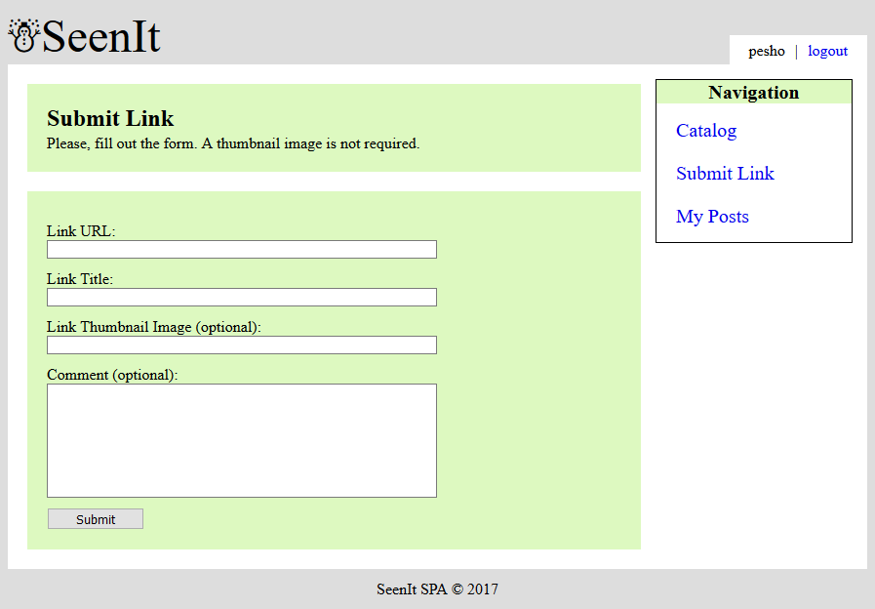

Edit Post Screen (10 pts)
Authors should be able to edit their own posts. Clicking the [Edit] link on each post should open an edit form. Inside the edit form all input fields should be filled with the current data of each post.
- After a successful post update, a notification message “Post {postTitle} updated.” should be displayed and the catalog should be shown.
- Link url and title are not optional, also link url should always start with “http”. In case of empty/incorrect input fields an appropriate error message should be displayed and the user should be able to fill the form again.
- Ensure you handle properly all HTML special characters, e.g. the message text could hold "Hi, <peter>".
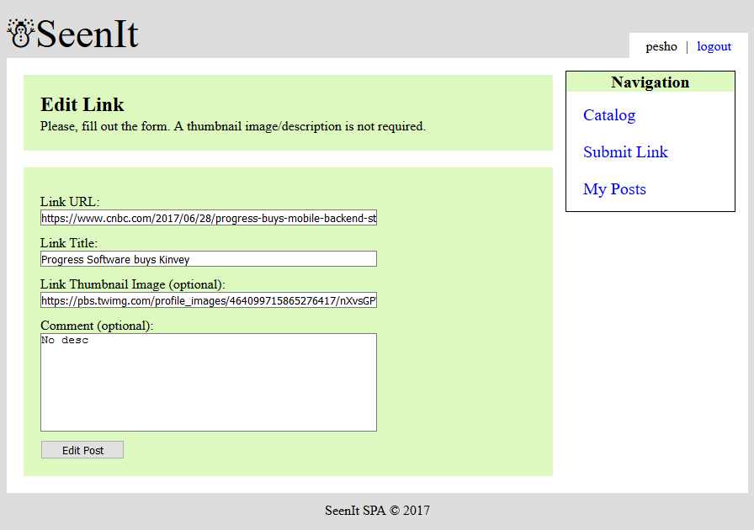

Delete Post (5 pts)
Authors should be able to delete their own posts by clicking the [Delete] button.
- After successful post delete a notification message “Post deleted.” should be displayed and the catalog should be shown.
- In case of error (e.g. Internet connection lost / unauthorized request / missing message), an error message should be displayed.
- Deleting works immediately, with no confirmation.

My Posts (5 pts)
Each user should be able to view his own posts by clicking [My Posts].
- The posts should be listed like in the catalog section.
- In case of error (e.g. Internet connection lost), an error message should be displayed.
- In case of no posts, display ‘No posts in database’.
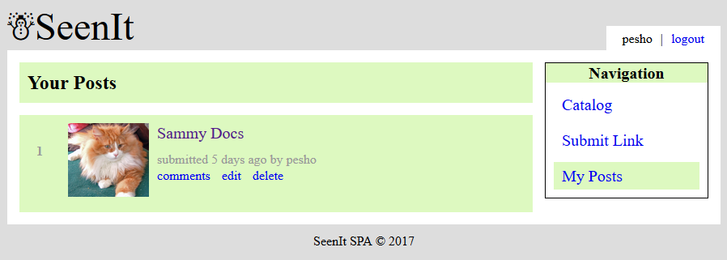

Post Details (15 pts)
Each post has a details view. By clicking the [Comments] link partial information about each post should be listed (post image, post title, post description), and most importantly each comment connected to the post.
- In case of error (e.g. Internet connection lost), an error message should be displayed.
- If there is no description add “No description” in it’s place.
- If there are no comments under the post display “No comments yet.”
- Each comment author has the ability to delete their own comment.
- Ensure you handle properly all HTML special characters, e.g. the message text could hold "Hi, <peter>".
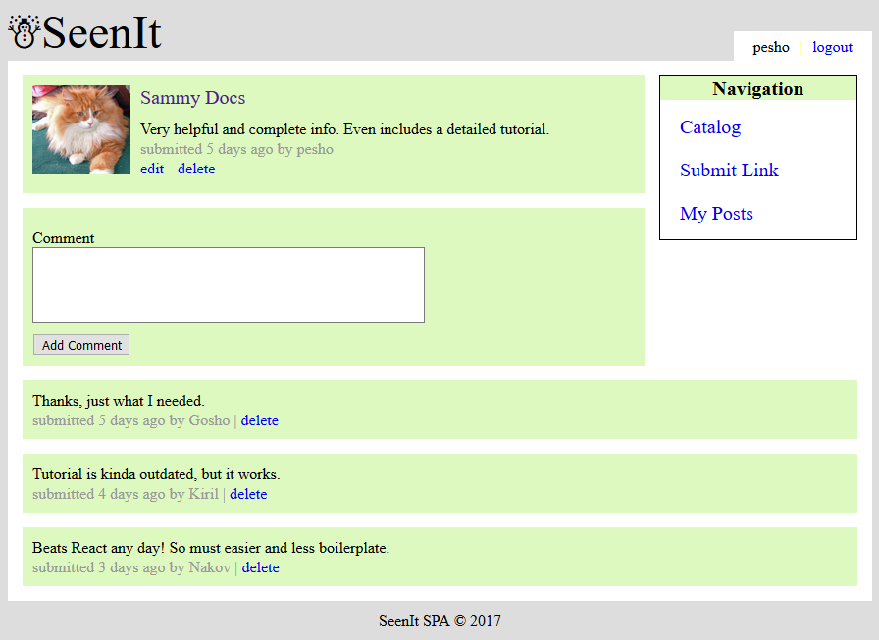

Create Comment (5 pts)
Every logged in user has the ability to create a comment under a post by clicking [Add Comment].
- After a successful comment creation, a notification message “Comment created.” should be displayed and the post details should be shown again with the newly added comment.
- Clear the input field after successful creation.
- Ensure you handle properly all HTML special characters, e.g. the message text could hold "Hi, <peter>".

Delete Comment (5 pts)
Every author has the ability to delete his own comment under a post by clicking [Delete]
- After a successful comment delete, a notification message “Comment deleted.” should be displayed and the post details should be shown again without the deleted comment.
- Ensure you handle properly all HTML special characters, e.g. the message text could hold "Hi, <peter>".

Subtmitting Your Solution
Place in a ZIP file your project folder. Exclude the node_modules folder. Upload the archive to the Judge.

